**Balanced and Unbalanced Forces**

For each of the questions below identify whether the forces are balanced or unbalanced. Write the resultant force and its direction. The first two questions have been completed as examples.

2. 

1.

6. 

8. 

7. 

9. 

5. 

12. 

11. 

10. 

4. 

3.

____________________________________________

____________________________________________

____________________________________________

____________________________________________

____________________________________________

____________________________________________

____________________________________________

____________________________________________

____________________________________________

____________________________________________

Balanced

0N stationary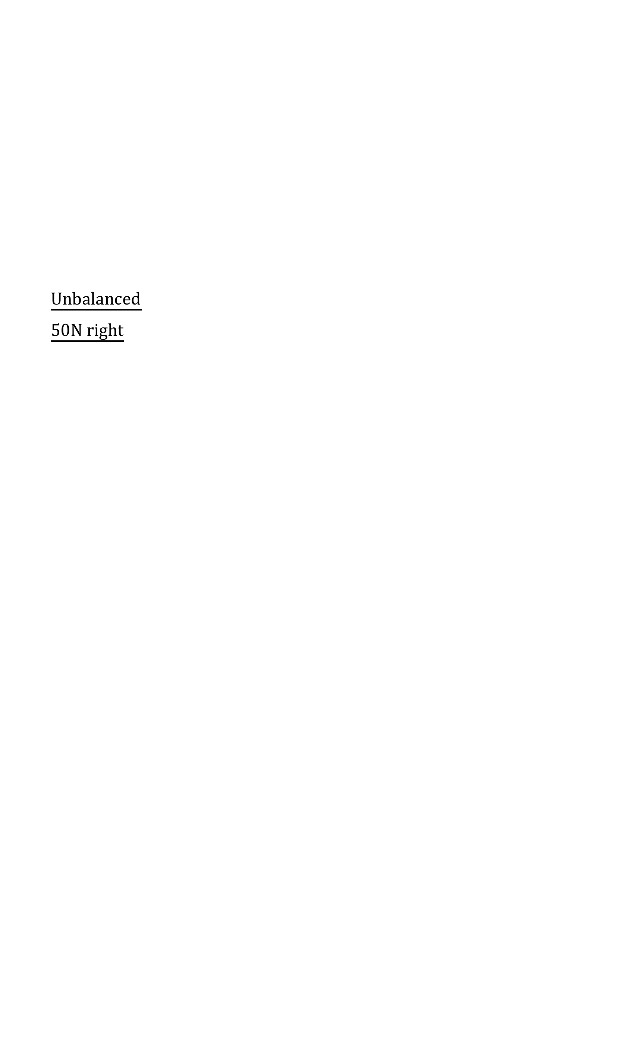

Unbalanced

50N right

100N

650N

145N

445N

3872N

3872N

7N

446N

295N

2N

2N

90N

97N

58N

28N

15N

30N

40N

50N

60N

40N

10N

10N

10N

Answers:

3. Unbalanced 10N left

4. Unbalanced 70N right

5. Unbalanced 300N left

6. Unbalanced 635N left

7. Balanced 0N stationary

8. Unbalanced 21N right

9. Unbalanced 237N right

10. Unbalanced 349N right

11. Unbalanced 50N left

12. Balanced 0N stationary